3. Setup a Jenkins CICD pipeline using Scripted pipeline using feature-1.1 branch. https://github.com/betawins/sabear_simplecutomerapp/tree/feature-1.1
stages:
Git Clone
SonarQube Integration
Maven Compilation
Nexus Artifactory
Slack Notification
Deploy On tomcat
Steps to create a scripted Pipeline in Jenkins
1. Log in to Jenkins
Open Jenkins in your browser (hTp://<jenkins-server>:8080/).
Log in with your creden3als.
2. Create a New Pipeline Job
From Jenkins Dashboard → Click “New Item”.
Enter a name for your job (e.g., My-Scripted-Pipeline).
Select Pipeline and click OK.
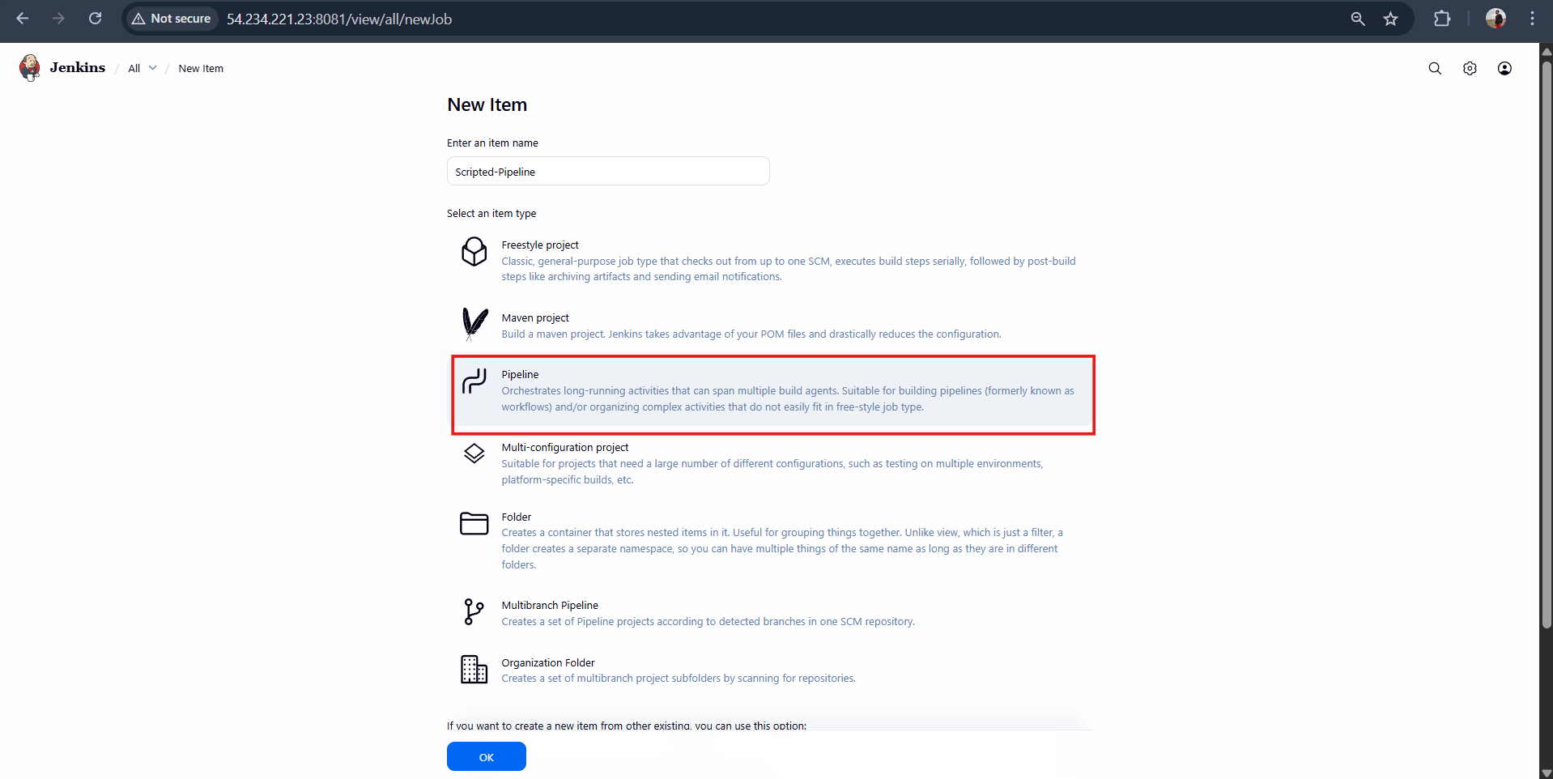
Scripted pipeline code:
node {

/* =========================
VARIABLES
========================= */
def SONAR_PROJECT_KEY = 'Sabear'
def SONAR_PROJECT_NAME = 'Sabear'

def NEXUS_URL = 'http://23.22.179.90:8081'
def NEXUS_REPO = 'simplecustomerapp'
def NEXUS_CRED = 'nexus_keygen'

def TOMCAT_URL = 'http://54.227.155.175:8080'
def TOMCAT_CONTEXT = 'simplecustomerapp'
def TOMCAT_CRED = 'tomcat_credentials'

def SLACK_CHANNEL = '#jenkins-integration'

/* =========================
TOOLS
========================= */
def mvnHome = tool 'MVN_HOME'
env.PATH = "${mvnHome}/bin:${env.PATH}"

try {

stage('Notify Build Started') {
slackSend(
channel: SLACK_CHANNEL,
color: '#439FE0',
message: "BUILD STARTED\nJob: ${env.JOB_NAME}\nBuild: #${env.BUILD_NUMBER}\n${env.BUILD_URL}"
)
}

stage('Git Clone') {
git branch: 'feature-1.1',
url: 'https://github.com/betawins/sabear_simplecutomerapp.git'
}

stage('Maven Compilation') {
sh 'mvn clean package -DskipTests'
}

stage('SonarQube Integration') {
timeout(time: 10, unit: 'MINUTES') {
withSonarQubeEnv('sonarqube-server') {
sh """
mvn org.sonarsource.scanner.maven:sonar-maven-plugin:5.5.0.6356:sonar \
-Dsonar.projectKey=${SONAR_PROJECT_KEY} \
-Dsonar.projectName=${SONAR_PROJECT_NAME}
"""
}
}
}

stage('Nexus Artifactory') {
withCredentials([usernamePassword(
credentialsId: 'nexus_keygen',
usernameVariable: 'NEXUS_USER',
passwordVariable: 'NEXUS_PASS'
)]) {

sh """
WAR_FILE=\$(ls target/*.war | head -n 1)

curl -u \$NEXUS_USER:\$NEXUS_PASS \
--upload-file \$WAR_FILE \
${NEXUS_URL}/repository/${NEXUS_REPO}/com/javahome/simplecustomerapp/${BUILD_NUMBER}/simplecustomerapp-${BUILD_NUMBER}.war
"""
}
}

stage('Deploy On Tomcat') {
withCredentials([usernamePassword(
credentialsId: 'tomcat_credentials',
usernameVariable: 'TOMCAT_USER',
passwordVariable: 'TOMCAT_PASS'
)]) {

sh """
WAR_FILE=\$(ls target/*.war | head -n 1)

curl -u \$TOMCAT_USER:\$TOMCAT_PASS \
-T \$WAR_FILE \
"${TOMCAT_URL}/manager/text/deploy?path=/${TOMCAT_CONTEXT}&update=true"
"""
}
}

stage('Notify Build Success') {
slackSend(
channel: SLACK_CHANNEL,
color: 'good',
message: "BUILD SUCCESS\nJob: ${env.JOB_NAME}\nBuild: #${env.BUILD_NUMBER}\n${env.BUILD_URL}"
)
}

} catch (err) {

stage('Notify Build Failure') {
slackSend(
channel: SLACK_CHANNEL,
color: 'danger',
message: "BUILD FAILED\nJob: ${env.JOB_NAME}\nBuild: #${env.BUILD_NUMBER}\n${env.BUILD_URL}"
)
}

throw err
}
}
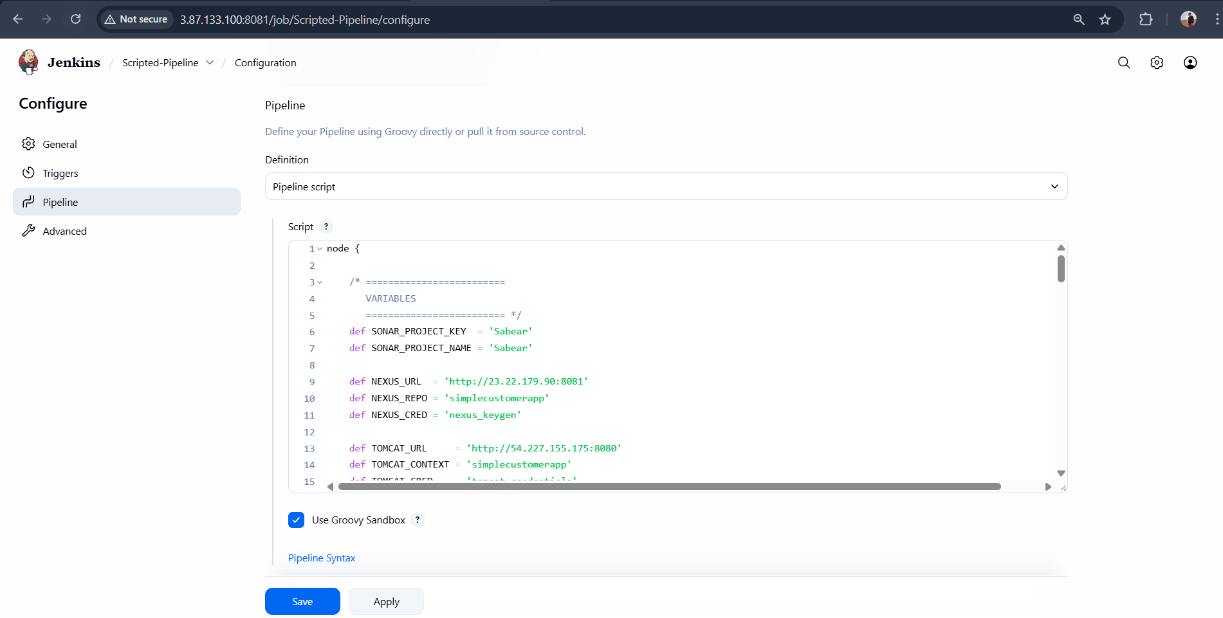
Click Save
Then Build now
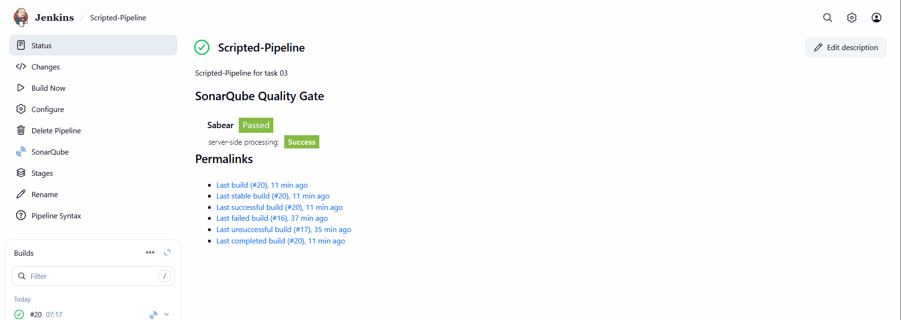
Check For console Output:
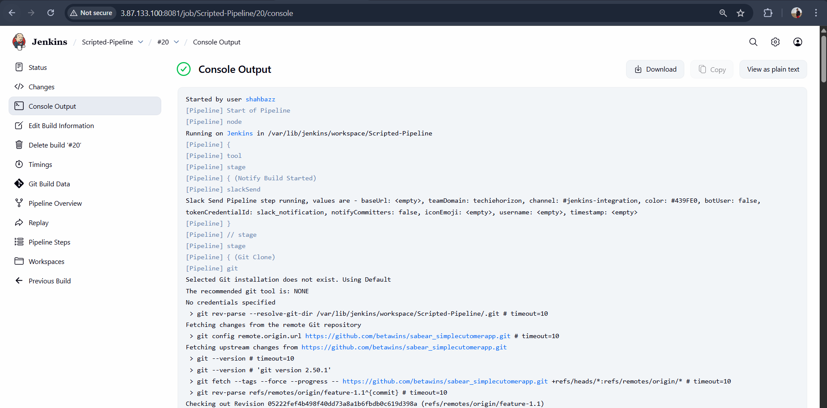
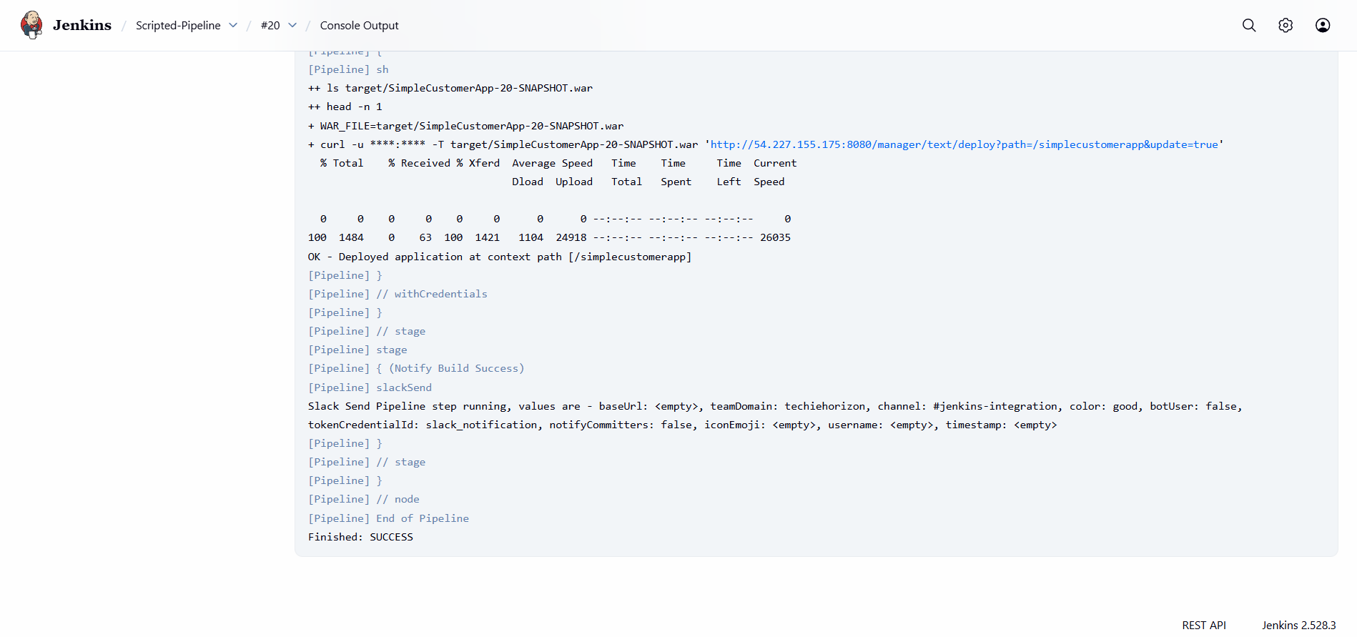
Sonarqube Integration:
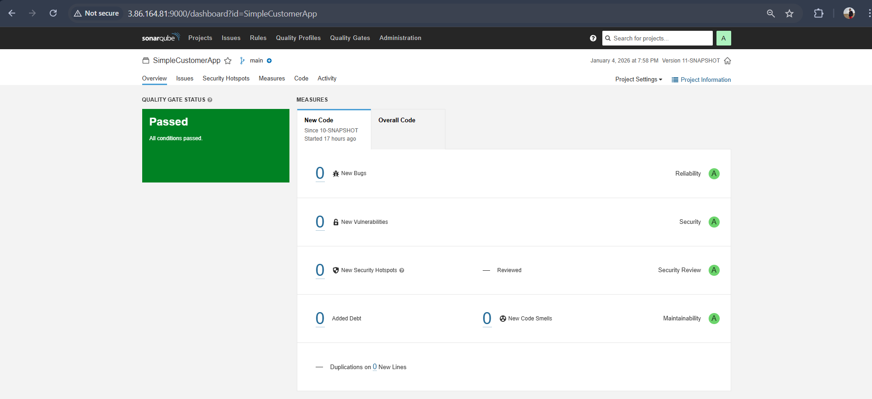
Validation code in sonarqube <check for quality of the code>:
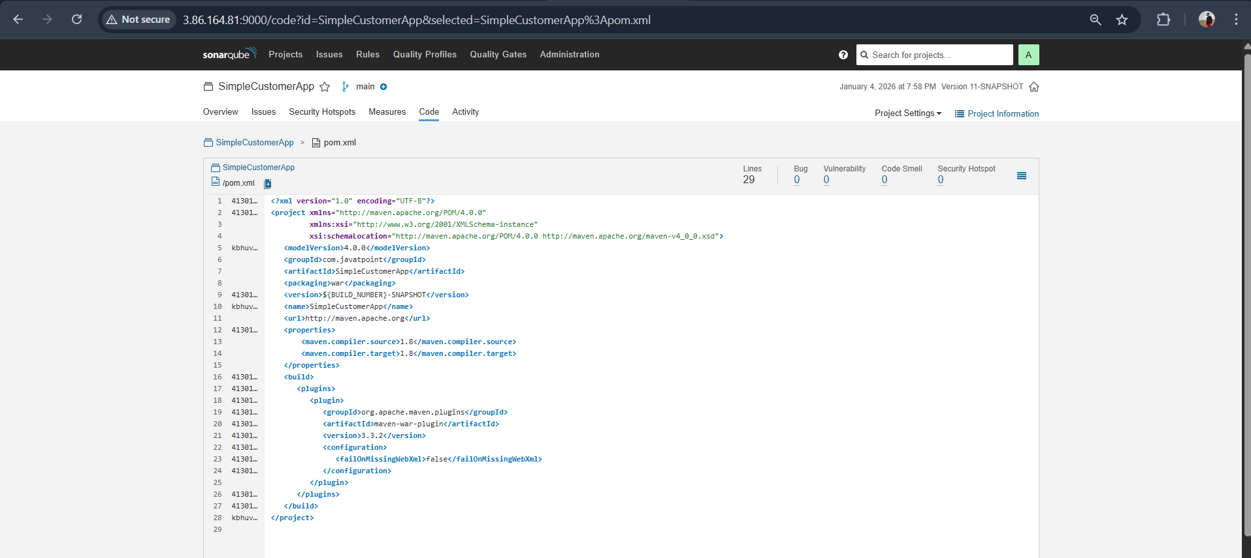
Slack Notification:
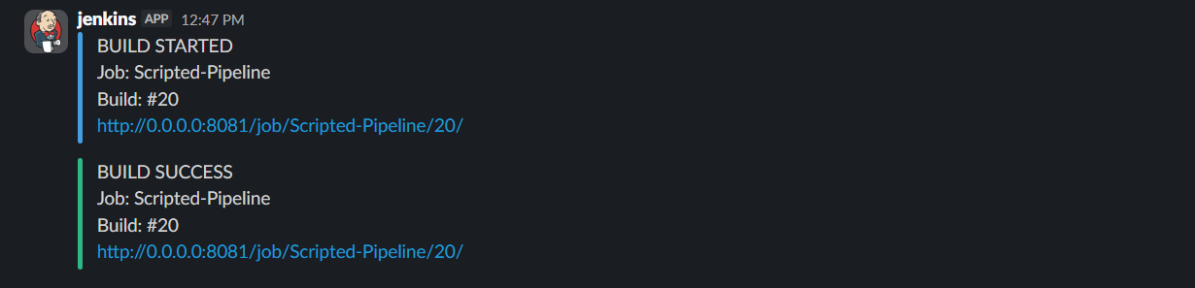
Deployed to tomcat: http://54.227.155.175:8080/simplecustomerapp/
